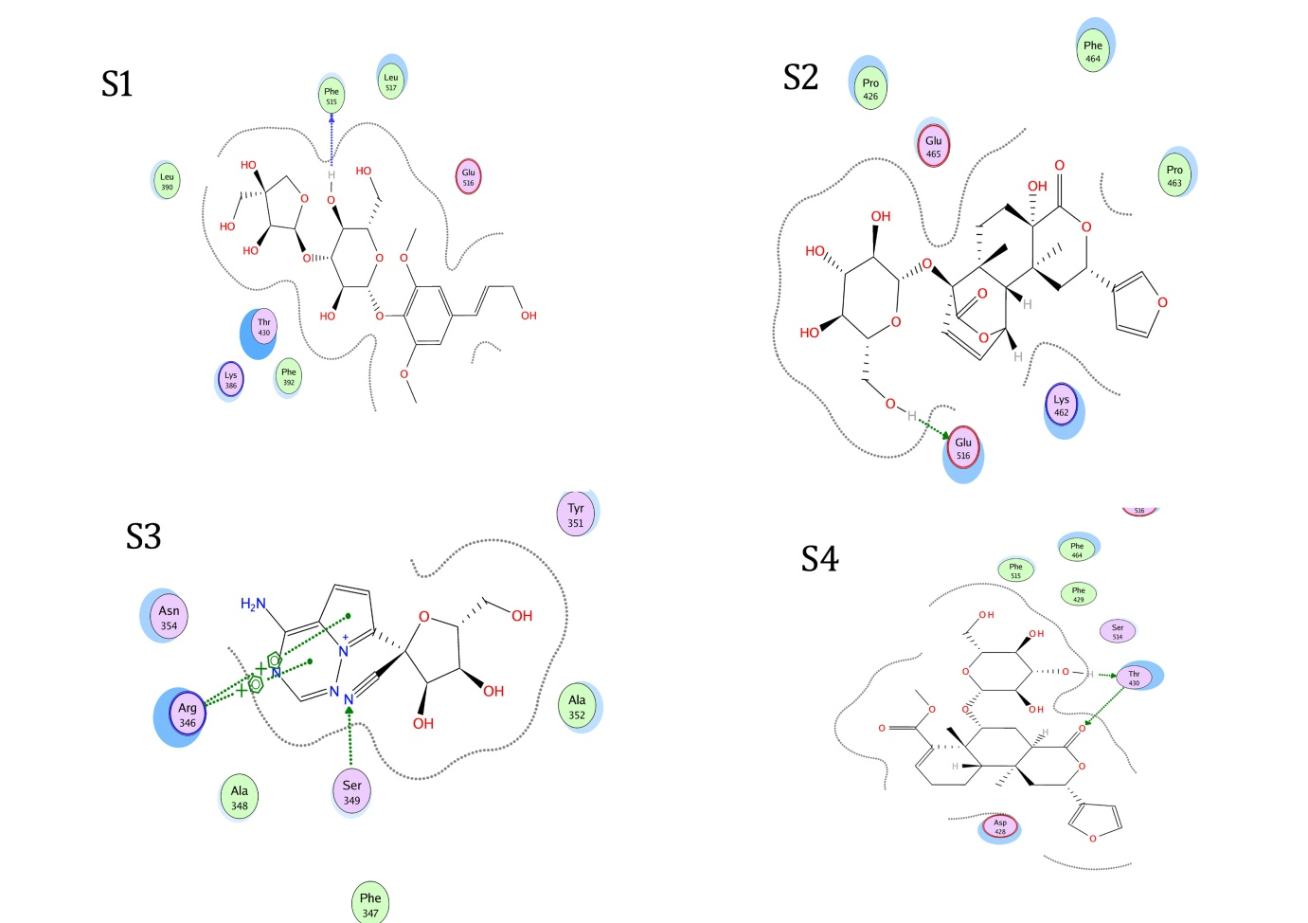

**Figure S1-S4**. 2D plot showing hydrogen bonding interactions: S1) Spike RBD-Remdesivir; S2) Spike RBD-Borapetoside C; S3) Spike RBD- Cordifolioside A; S4) Spike RBD - Tinosinenoside A

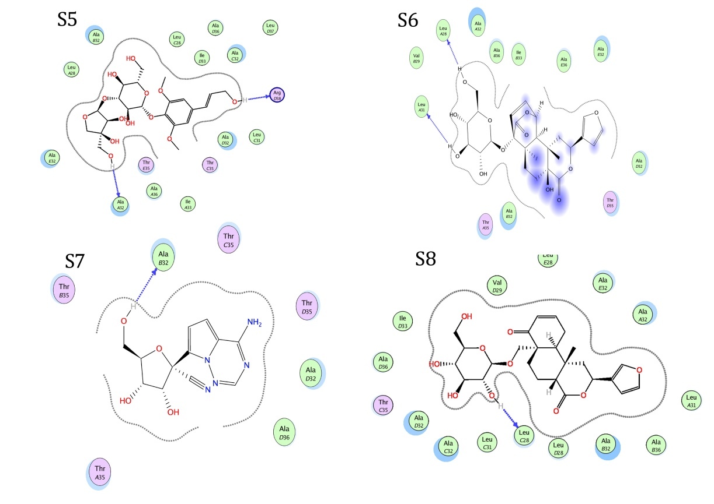

**Figure S5-S8**. 2D plot showing hydrogen bonding interactions: S5) Envelope TMD-Remdesivir; S6) Envelope TMD -Palmitoside G; S7) Envelope TMD- Cordifolioside A; S8) Enveope TMD-Tinosinenoside A